**REST** -> **RE**presentation **S**tate **T**ransfer

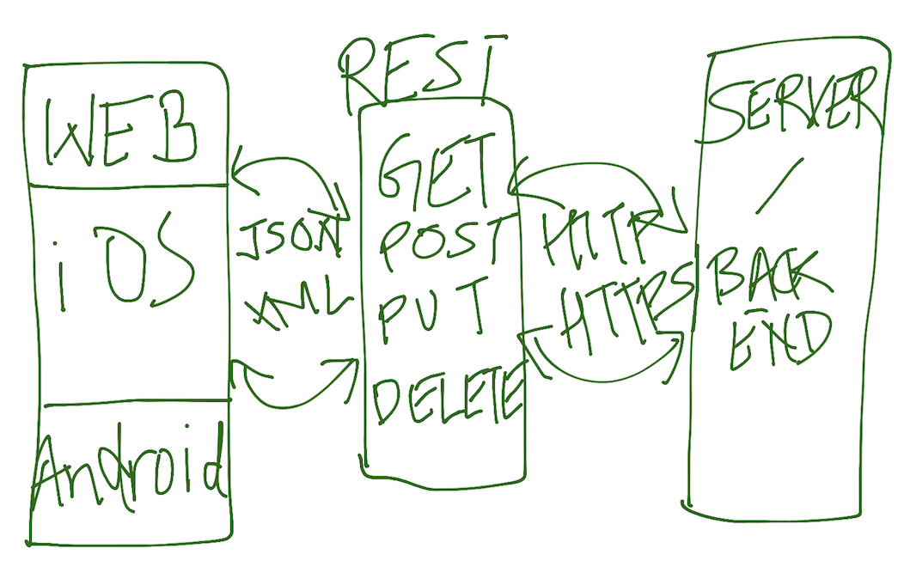

Representation -> How resources are manipulated

REST API uses JSON/XML for data. -> Payload

We create request in the form of JSON/XML and we also get response from the RESTAPI in the form of JSON/XML only

It is stateless -> Client data is not stored on the server, session data is also stored on the client

It uses http/https protocol and it makes it language independent

RESTAPI can be written in any language and developers in any language can consume it

**Endpoints:**

Endpoints contain:

1. URIs -> This is the essentially the endpoint (Address of the resource where to contact) Unique Resource Identifier
2. Resources -> Which specific thing we want - navigate to a page and then show
3. Parameters - Used to filter the resources. When we want to get specific data from the resource
4. There are 4 important HTTP Keywords (GET, PUT, POST, DELETE)
5. These keywords are knows are types of request
6. Response -> HTTP (Status, body, Headers)
7. Payload -> Data that we send to Rest with the request

**GET** -> It is used to retrieve the information from the server/app

Parameters can be provided as part of the URI

**POST** -> It is used to create new information on the server/app

Request should be provided as JSON/XML request as Payload

**PUT** -> It is used to update/modify the existing information on the server/app

Request should be provided as JSON/XML request as Payload

**Delete** -> It is used to delete the information from the server/app

Request should be provided as JSON/XML request as Payload

**Headers:**

Header contains information about the request and response.

Sometimes you may have to authenticate to the website and show that you are authorized to access the resource

Some resources on the application may be secured and may not be accessible directly

That information is contained in headers

Also content-type -> This information also exist in headers